Chapter 11 How to create and maintain databases, tables, and sequences with SQL statements
- Before you begin, please review the problems at the end of Chapter 11 in the textbook. You will find the solutions to these problems in the book files:
Murach\SQL Server 2012\Exercises\Chapter 11
- Write a script that implements the following design in a database named MyWebDB:
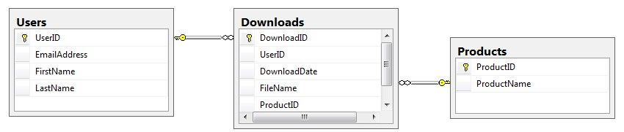
In the Downloads table, the UserID and ProductID columns are the foreign keys.
Include a statement to drop the database if it already exists.
Include statements to create and select the database. Include any indexes that you think are necessary.
Use appropriate data types and constraints.
You can execute your script incrementally: create the database first, then the tables. Click the refresh button in the Object Explorer so your new database and tables will be visible.
Your screen shot(s) should show the script and the Object Explorer AFTER the script is executed showing the new database and the tables you created.
- Write a script that adds rows to the database that you created in exercise 2. You can make up the values. Add two rows to the Users and Products tables.
Add three rows to the Downloads table: one row for user 1 and product 2; one for user 2 and product 1; and one for user 2 and product 2. Use the GETDATE function to insert the current date and time into the DownloadDate column.
Write a SELECT statement that joins the three tables and retrieves the data from these tables like this:
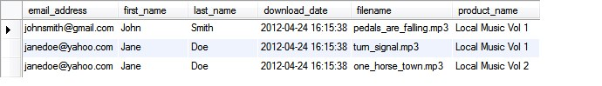
Sort the results by the email address in descending order and the product name in ascending order.
- Write an ALTER TABLE statement that adds two new columns to the Products table created in exercise 2.
Add one column for product price that provides for three digits to the left of the decimal point and two to the right. This column should have a default value of 9.99.
Add one column for the date and time that the product was added to the database.
Show your results with a SELECT * statement.
- Write an ALTER TABLE statement that modifies the Users table created in exercise 2 so the FirstName column cannot store null values and can store a maximum of 20 characters.
Code an UPDATE statement that attempts to insert a null value into this column. It should fail due to the not null constraint.
Code another UPDATE statement that attempts to insert a first name that’s longer than 20 characters. It should fail due to the length of the column.

